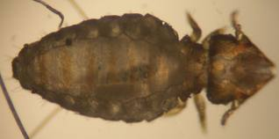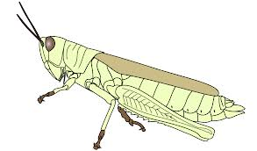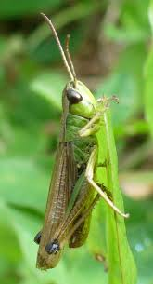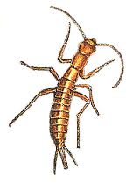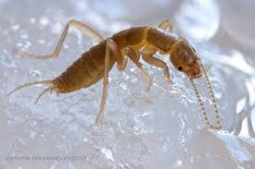

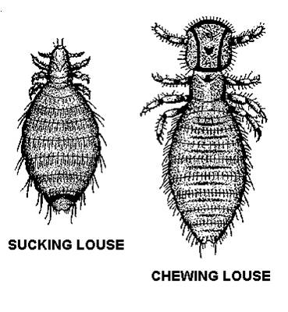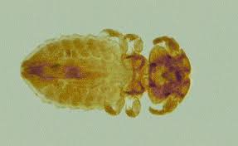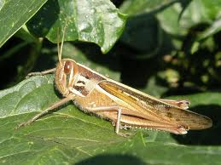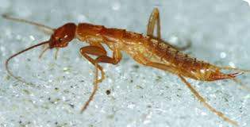

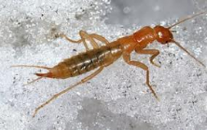

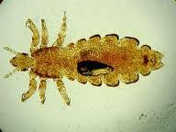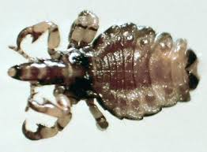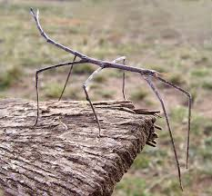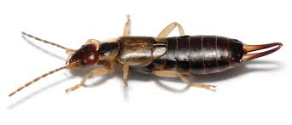

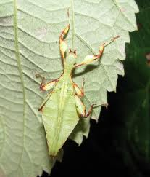

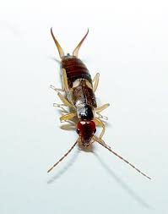

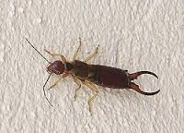

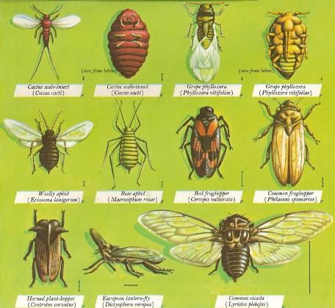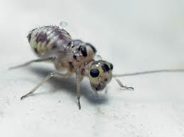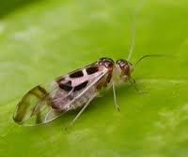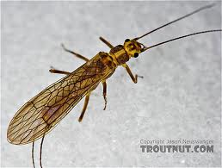

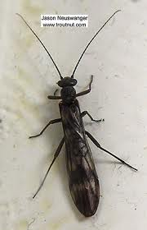

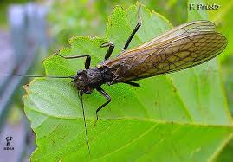

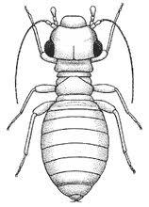

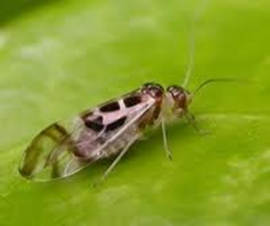

**Orthoptera – grasshoppers and crickets**

Hemimetabola (incomplete development)

Terrestrial herbivores and hind legs adapted for jumping

Ability to make and detect sounds

Feed on plants and cause serious economic damage

For families go to 2.

**Hemiptera – true bugs**

Hemimetabola (incomplete development)

First pair of wings is toughened and hard and the rest of the first pair and second pair are membranous

Modified piercing and sucking mouthparts

For families go to 3.

**Anoplura – Sucking Lice**

Hemimetabola (incomplete development)

Biting lice – sectorial mouthparts

Cannot survive long if separated from body and host

Lice have no wings so disperse through host direct contact

Responsible for the spread of disease

**Mallophaga – Biting/Chewing Lice**

Hemimetabola (incomplete development)

Biting lice – presence of mandibles that are suitable for biting

Cannot survive long if separated from body and host

Lice have no wings so disperse through host direct contact

Head broad, mandibulate mouthparts

**Psocoptera – book and bark lice**

Hemimetabola (incomplete development)

Bark lice live in moist terrestrial environments

Live in small colonies

Booklice are wingless and found in human dwellings

Few live in nests of birds

**Phasmatodea – Walking stick**

Hemimetabola (incomplete development)

Common in tropical and subtropical climates

All species are herbivores

Females don’t have an ovipositor

Wings are often reduced or absent

**Plecoptera – stone flies**

Hemimetabola (incomplete development)

Represent an evolutionary “dead end” that diversged

Immature are aquatic

Feed on algae or vegetation

Extremely sensitive to water pollution

**Dermaptera - earwigs**

Hemimetabola (incomplete development)

Mostly scavengers or herbivores a few are predatory

They fold to fit beneath the front wings when not in use

Cerci at the end of the abdomen and thickened

**Grylloblattodea – ice insects or rock crawlers**

Hemimetabola (incomplete development)

Really rare and found in caves or near ice or snow

Omnivorous

Active only at cold temperatures